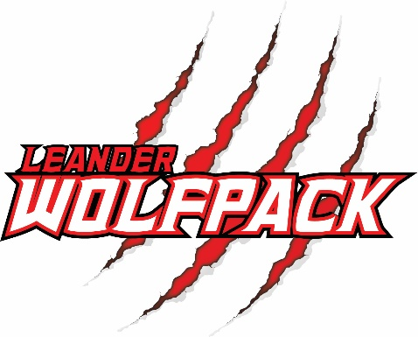
Leander Youth Football and Cheer
Gear Checklist
Tackle Football Checklist:
- White Football Helmet (decals will be provided w/ registration)
- Shoulder Pads
- Football Cleats (non metal)
- Mouth Guard (we recommend those that attach directly to the helmet and suggest you buy a few for the entire season)
- Practice Pants with Padding
- Practice Jersey (any color, preference given to Red & Black if available)
- Water Jug
Suggested, not required:
- Compression/padded undershirt (a t-shirt will work fine and they will get one for game days)
- Practice socks

Flag Football Checklist:
- Football Cleats
- Red shorts, no pockets
- Mouth Guard (buy extra, they get lost!)
- Soft Helmet
- Water Jug

Cheer Checklist:
- Team colors any combo of red/black and white sorts and top for practice
- Cheer shoes:
  - https://www.amazon.com/dp/B07X3J5345/?coliid=I3MGJER381IFXQ&colid=RWS70Y04326P&psc=1&ref_=lv_ov_lig_dp_it or
  - https://www.amazon.com/dp/B09K7FTLBN/?coliid=I5958B48YPWHS&colid=RWS70Y04326P&psc=1&ref_=lv_ov_lig_dp_it
- White no show socks
- Hair back and off the face
- No jewelry (studs included)
- Lots of water (30+ oz)
- Sunscreen

